# Battleship

Requirements

1. **Introduction and Context**

*The project that we want to build is a multiplayer form of the board game battle ship consisting of two players. Essentially, players will use a lobby to join a game then each player in a game will take turns trying to shoot down other players boats on a specified sized board by choosing different coordinates to shoot at.*

1. **Actors and their Goals**

There are three main actors in our system: Player, Game Manager, and Lobby. The goals for these actors are outlined below

Player:

* One actor is the player and the goal is to beat the other player in battleship.
* Connect to the lobby.

Game Manager:

* Manage game state and communicate it to the Players.
* Communicate with players to change the game data.
* Connect to lobby.

Lobby:

* Facilitate connecting players to Game Managers.
* Find players and hold players until a game is started.

1. **Functional Requirements**

*This project will have three processes, client, lobby and game.*

*The player will handle: Display board, player’s placement of ships, make a guess as to where another player’s ship is, and connect to the lobby.*

*The lobby will handle: Storing information about users, connecting two players to a game, initiating the connection of game managers and clients for a new game, and keep the count of current games being played.*

*The game manager will handle: keeping score and which players are currently in a game*

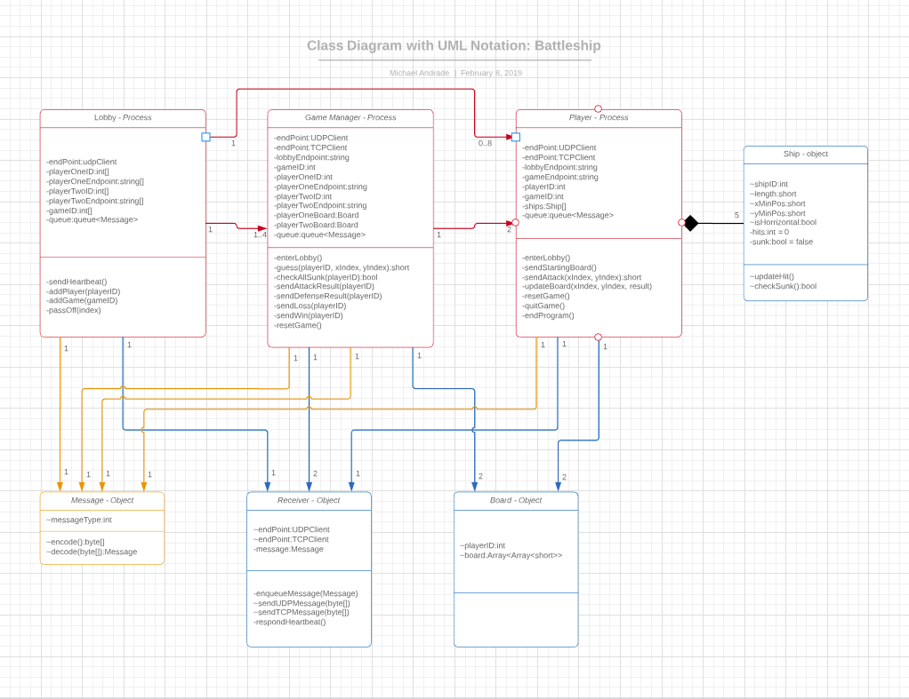

1. **Non-functional Requirements**

*In this project we will use C# as the programming language.*

*We will use Visual Studios to create this project.*

*Proposal will be finished by Feb 9, 2019.*

*For each class we will have unit testing.*

*This project will be planned to run on the Windows operating system.*

1. **Future Features**

*Future ideas include: Keeping a record of two players record against each other. Creating sounds for indications when one of your boats have been shot or sunk. The ability for clients to spectate ongoing games. Password protected lobbies. Allowing more than 2 players to connect and play together and play a version of battleship that includes more than 2 players.*

1. **Glossary**

Shoot - Refers to a player picking an X and Y coordinate as a guess of where his opponent set his ships.

Ship - A set of coordinates that run in a horizontal or vertical line of a set length.

Win - A player when when he has “shot” down all the other players ships.